Independent University, Bangladesh

Department of Computer Science & Engineering

CSE 307: System Analysis and Design

(Summer 2019)

Assignment 1 (40 Points)

Statement of Work

Due on May 22, 2019

Instruction:

· Save the file with the naming convention as

A1_CSE307Summer2019_ID_FIRST NAME_LAST NAME.docx

· Submit through Piazza.com under folder assignment1 to the Instructor as Question.

· In summary please follow the convention: A1, ID, First Name Last Name

Tasks:

1. **Choose you project**

For this project I have chose to develop a web and mobile based application which helps people with their diet (meals).

It will be accessible from all platforms, hence making it easier to plan the user’s meal and be more cautious towards their health.

It will be a joint venture for any medical institutions and food places.

2. **Project goal and objectives**

Information in this modern day and time is very valuable and

abundant. In the vast amount of information, it is difficult and time

consuming to filter out the necessary details. People are also growing

more self conscious and self aware towards their health, nutrition and diet plan.

Our main goal for this project is to ensure that there is easy access to information so that everyone can achieve a healthier lifestyle.

The software solution provided will save time finding the proper recipe to make the right meal, and the nutritional values of the food. It will also save time by keeping the option to go and eat the specific meals out at any restaurant or get home delivery for their food.

The food they will get will also be healthy.

3. **History leading to project request**

There is a need for a diet-nutrition solution in the status quo given the

lack of any similar product like our model currently.

Day by day, the modern generation are growing more health and time

conscious. People are opting for convenience in their activities.

People want to save time from going to the doctor and finding a

healthy diet plan, or where to find the required food from a healthy

and reliable source to make those dishes for their diet plans. It is

inconvenient finding reliable diet information online from the vast

information.

This application will help with the health of those who use it. The government will also find it useful as will the hospitals, groceries and shops and restaurants.

4. **Identify Problem, Solutions & Opportunities**

> Problems

* People are more health conscious

- Time consuming to go to nutritionists for diet plan

- Time consuming to find place to eat healthy

- Time consuming to find place that sells required ingredients which are healthy

- Time consuming to find nutritional information

- Time consuming to find good doctor and to set up appointment for checkup

- Travelling physically is time consuming due to traffic

- Time consuming and difficult to find reliable and relevant medical and diet information online from the vast amount of information.

- Traffic, and incontinence going to doctor/finding healthy diet to eat/good places where they sell the ingredients or make those dishes

- Incontinence finding reliable medical/diet information online from vast information

> Solutions

Web/mobile based solution to find healthy dishes to eat, places to eat them, how to make them, home delivery, and more awareness on what you are eating and relevant information at fingertips.

Our solution will provide a healthy personalized diet plan and will make it easier for the users to eat healthy and prepare healthy meals based on their personal information.

Chefs and cooks will be working alongside with medical nutritionists so as to provide healthy dishes and recipes and the food places which prepare those foods will be listed to the users.

> Opportunities

With the help of the government, and media, and more funding, we can expand our solutions reach and bring onboard more people and increase the stakeholders.

Having more nutritionists and cooks will help increase the number of food items and dishes, thus increasing the variety of food for the users. This will make them more interested to use our service and will bring on more potential users.

5. **Product Description:**

a. **Product Summary**

The software solution we proposed will connect the medical experts, cooks, food joints, grocery stores, payment companies, and health concerned or food enthusiastic users.

The health experts will provide information and guidelines on the proper diet and nutritional facts, which will be stored in our application.

The cooks will provide recipes keeping in par with the health requirements.

The restaurants will serve the dishes curated by the cooks.

The groceries will provide the fresh supplies of produce to the restaurants.

The users will provide their information and get their diet plan.

They will buy the dishes from the restaurants or will use the recipes and make it themselves using the produce from the groceries.

b. **Product Stakeholders**

- Users: Who are looking to better their health and eat healthy

- Restaurant / Food joint owners: Who will provide updated information on their Menus and items they are selling with price, and location. They will also cook the recipes of healthy dishes provided by the chefs/cooks who have been briefed by the nutritionists.

- Superstores / Shops / Grocery stores: Who will provide updated information on items they are selling with price, and location

- Hospitals / Doctors: Who will give a balanced diet plan based on food stuffs and nutritional facts

- Chefs / Cooks: Who will combine the ingredients in the diet plans to make different healthy dishes

c. **Context Level Data Flow Diagram**

- Hospitals / Doctors -> Food meal plans, diet menus + Nutritional values + Ingredients/food items

- Grocery -> Supplies the ingredients

- Restaurant/Food joints -> Buys ingredients based on doctors’ plans + Prepares recipes/foods based on that

- User -> Gives personal information for personalized diet plan, gives allergies, location, age, food preferences, dish preferences, spice/sweet/savoury, home delivery, or recipe or parcel, or go and eat

Gets information based on inputs

Can order online using bKash, CCard, DCard, On Delivery

- Payment Companies -> Help with monetary transactions

- Cooks/Chefs -> Help provide healthy dishes using the nutritional requirements from the nutritionists

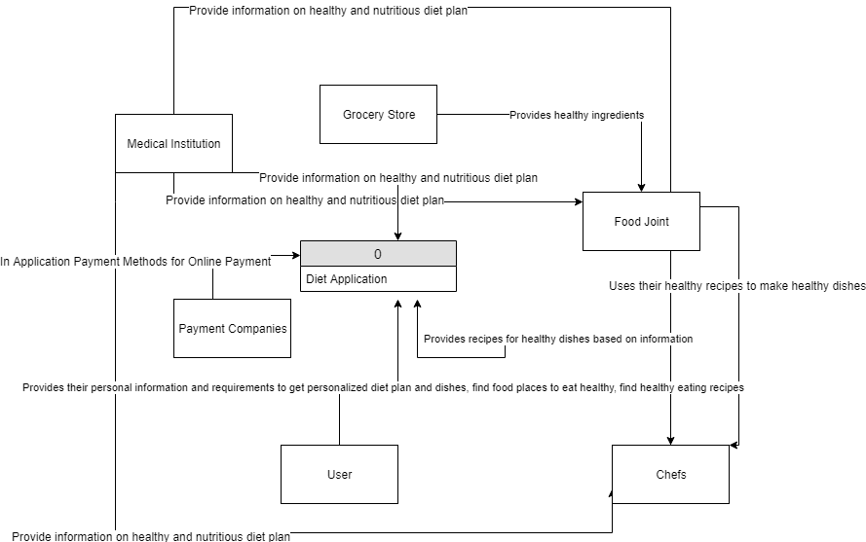

Data Flow Diagram

d. **Software key technical features**

- Our Software is an online web and mobile application

- It will have forms to take information from user (location, age, gender, phone number 1 2. allergies, weight, preferred diet plan, preferred ingredients, preferred calorie intake, time of meal)

- It will show recipes of dishes based on requirements, show diet plans based on requirements and dishes, show restaurants/food joints based on dishes and location, and price, and nutritional values, time for preparation, takeout/parcel, drive through

- Users can make the dish themselves using the recipes

- They can order the food using the Application

- They can pay using bKash, or credit card

- There is also option for Home delivery as well as Drive Through or Parcel

- Pictures of the dishes will also be shown on the Application

- Nutritionists will provide medical health diet information

- Cooks will use medical information to make healthy dishes and provide the recipes

- Restaurants will provide the dishes using the recipes provided

- Groceries will provide the produce required in the recipes

- Users can also find groceries to buy ingredients

e. **Hardware Details (Include Rich Picture)**

A cloud based web server to host website

Mobile app version too

Android Mobile

Chrome Browser

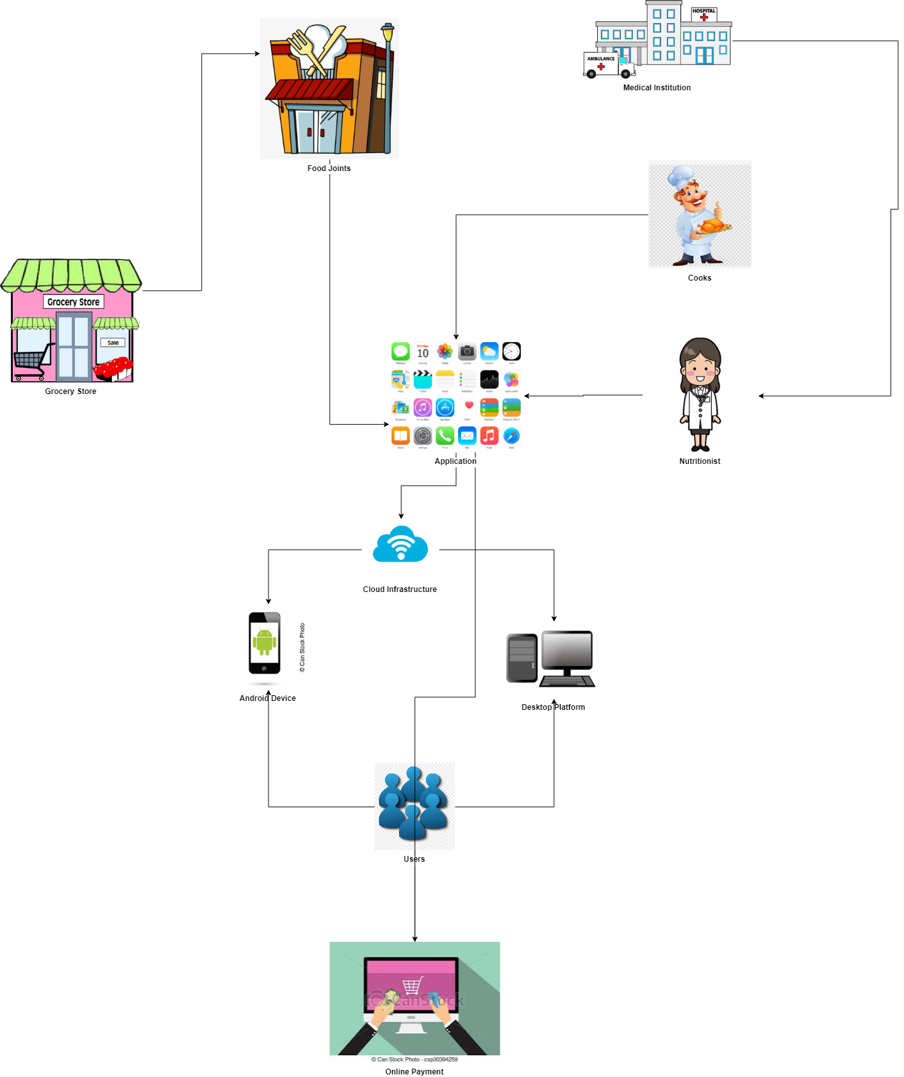

*Rich Picture of System*